CCH CGT and Dividend Transactions Import

Specification

Legal Notice
    - Disclaimer
CCH Software has made every effort to ensure the accuracy and completeness of these Release Notes. However, CCH Software, its staff and agents will not be liable for any errors or omissions and use of the software is subject to the customer’s licence with CCH Software. These Release Notes should not be relied upon as a detailed specification of the system or the software.
CCH Software may make changes to these Release Notes from time to time.
    - Copyright
These Release Notes may not be copied, altered, edited, disposed of or distributed without the prior consent of CCH Software. The content is confidential.
Unless indicated otherwise all elements of this software production are owned by Wolters Kluwer (UK) Ltd.
© 2013 Wolters Kluwer (UK) Limited (trading as CCH Software)
    - Trademark Rights
Microsoft, Windows, Windows NT, Windows for Workgroups, Windows 98, 2000, XP, MS-DOS, Windows Vista, Windows 7, Windows Server, Microsoft SQL Server, and Microsoft Office, are either registered trademarks or trademarks of Microsoft Corporation. Novell and NetWare are trademarks of Novell Inc. Citrix MetaFrame is a registered trademark or trademarks of Citrix Systems, Inc., All rights reserved.
All other trademarks are the property of their respective owners.
CCH Software
145 London Road,
Kingston Upon Thames,
Surrey
KT2 6SR
Contents
Overview 1
Detail 2
CSV Files 2
Import File Format 2
Processing 3

Overview
There is an option to import transactions into CGT&DS from a file. This option is found under File > Open > Import/Export > CGT and Dividend Scheduling - Import Transactions from file. 2 file formats are accepted:
- IMP file format which is compatible with Legacy Gains but has many limitations.
- CSV file format which was written for CGT and Dividend Scheduling and overcomes these limitations.
This specification describes the CSV file format.

IMP File Format
The old style IMP format was used to import data into legacy CCH Gains and is still supported although it has certain limitations and it is no longer the recommended format:
- It can only be used if the portfolio references are unique as there is no ability to specify the client code with this format.
- It only recognises securities by SEDOL code or CCH code, depending on which code type the user is licensed for. External sources do not use the CCH code which makes this format only useful for SEDOL code users.
- The file format is not very easy to generate.

CSV File Format
The CSV format was developed to overcome these limitations. It has the following advantages:
- You can reference the portfolio using the client code (and the portfolio reference if the client has more than 1 portfolio).
- Alternatively you can reference the portfolio using the broker's account number.
- With this format the system recognises security codes which are SEDOL or ISIN codes, even if the system is licensed for CCH codes.
- The file format is easily created from an Excel spreadsheet.

Detail

CSV Files
The CSV file is usually created in Excel and saved using a File Type of CSV file. The CSV file is a text file which contains the data from the spreadsheet but excludes formatting such as emboldened text and column widths. The CSV file can be opened and examined using a text editor such as Notepad and it will be seen that the columns in Excel have been replaced with commas:
A,Tran,I,C,POST,P1,A041764,01/01/13,PUR,1000,2000,My shares,
A,Tran,I,C,POST,P1,0076700,01/01/13,PUR,1000,2000,My shares,
It is also possible to double-click on the CSV file and it will reopen it in Excel. If this is done then leading zeros are removed from security codes and it may be necessary to reformat the column to show leading zeroes using a custom format of "0000000".

Import File Format
The format of the file to be imported into CGT&DS is as follows:
Field Name | Description | Note
Action Code | A=Add  D=Delete (matching on portfolio, date, security, quantity and amount)
Record Type | Tran=Transactions | Mandatory. No other options
Transaction Type | I=Inv Tran | Mandatory. No other options
Client code type | C=Client  B=Brokers' account number | Mandatory
Client code | Alphanumeric | Mandatory. Client code or Brokers' account number
Portfolio code | Alphanumeric | Mandatory if Client code type=C and client has more than 1 portfolio. Otherwise ignored
Security code | Alphanumeric | Mandatory. CCH, SEDOL or ISIN. Dashes in the code are not required, e.g. use 0884709, not 0-884-709.  If CGT&DS uses CCH codes then ISIN codes can be looked up on the masterfile. SEDOL codes may need to be looked up on CCH's Code Lookup service which requires an internet connection and may cause a few seconds delay.
Date | dd/mm/yy or dd/mm/yyyy | Mandatory. On a BFD it determines the portfolio period and should be the period start date.
Inv Tran Type | BFD=Brought Forward (not yet i8mplemented)  PUR=Purchase  SAL=Sale  DIV=dividend or interest | Mandatory
Quantity | Number | Mandatory for BFD, PUR, SAL. Positive for both PUR and SAL
Amount | Number | In GBP
Description | Alphanumeric | Applies to PUR/SAL where it is the "Alt. Description" field.
Accrued interest | Number | Optional. Only applies to PUR/SAL. On a PUR positive means accrued income allowance; on a SAL positive means accrued income charge
UK Tax | Number | Optional. Only applies to DIV. Can be CALC for calculate at 10%/20%
Foreign tax | Number | Optional. Only applies to a DIV.
B/Fwd indicator | Alphanumeric | N=New pool, E=exempt, R=relevant
CGT Date | Date | Applies to BFD with B/Fwd indicator=N or R
CGT Value | Number | Applies to BFD. If specified, generates an Opening Balance. The B/Fwd has the CGT Value as the amount and the OpBal has the Amount.

Processing
In Central after selecting Import Transactions and selecting the CSV file, the following screen appears:
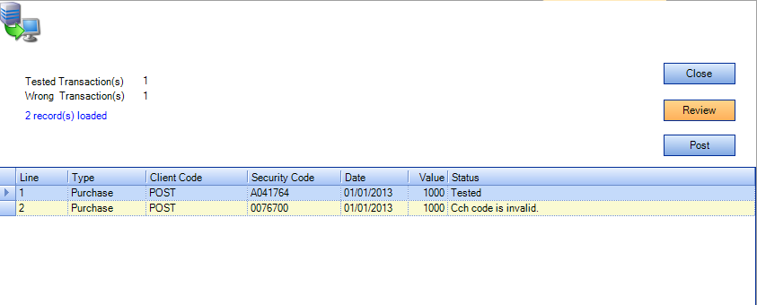
After clicking Review the system shows that the first transaction is Valid and the second is invalid and a reason is given. If Post is pressed the first transaction will be imported and the second will not.

